Program CA17128 LignoCOST Co-located joint Working Groups + 2nd MC meeting

Dates: March 13 - 15, 2019

Venue: WICC, Wageningen International Congress Centre
Lawickse Allee 9, 6701 AN Wageningen, The Netherlands
www.wicc.nl/en/

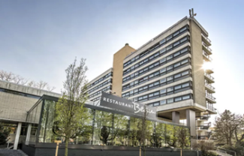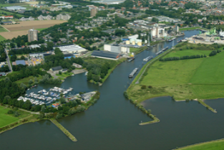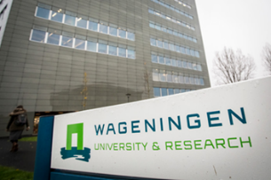

Tuesday March 12
20.00-21.00 | Welcome reception | WICC

Wednesday March 13
9.00-9.30 | Registration / coffee | Registration desk / plenary room
9.30-10.30 | Overview of CA 17128 LignoCOST (chair) | Plenary room
10.30-12.00 | Introduction of working groups (working group leaders)  15 min each WG | Plenary room
12.00-13.30 | Lunch
13.30-15.30 | Introduction to working group (3 slide intro p.p.) | 5 rooms
15.30-16.00 | Group photo + coffee break
16.00-17.30 | Speed dating per WG | 5 rooms
19.00 | Dinner

Thursday March 14
8.30-9.00 | Helpdesk Grant Holder (reimbursement rules)
9.00-10.30 | Tasks and action plan each WG | 5 rooms
10.30-11.00 | Coffee break
11.00-12.30 | Continue tasks and action plan each WG | 5 rooms
12.30-13.30 | Lunch
13.30-15.00 | Feedback from working group (working group leaders /  15 min) | Plenary room
15.00-15.30 | Coffee break / tour info
15.30-17.30 | Guided tours (botanical garden/city of Wageningen)
19.00 | Dinner

Friday March 15
8.30-9.00 | Helpdesk Grant Holder (reimbursement rules) | Room
9.00-10.30 | Results and achievements Grant Period 1  Financial closure of GP1
Decisions for MC:
Deputy working group leaders
STSM + ITC grant manager / core group
International experts
10.30-11.00 | Coffee break
11.00-12.30 | Working & Budget Plan Grant Period 2  Events, n STSMs, n ITC grant, dissemination
12.30-13.30 | Lunch
Route description
